Homeowner Portal Sign Up

1) Visit our website at www.Talega.Today and click either “Homeowner Portal” in our menu or “Member Log In” on the front page | 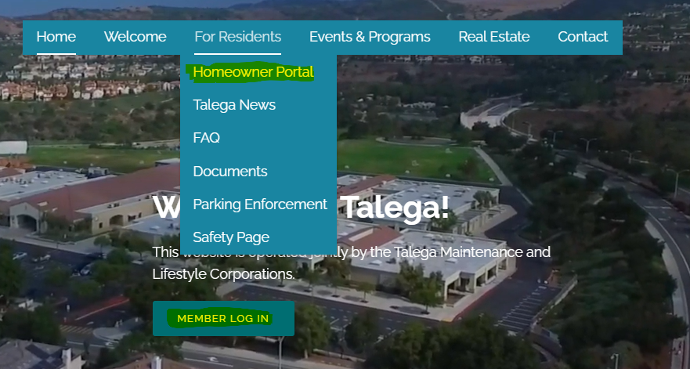
2) Click “Create Account” | 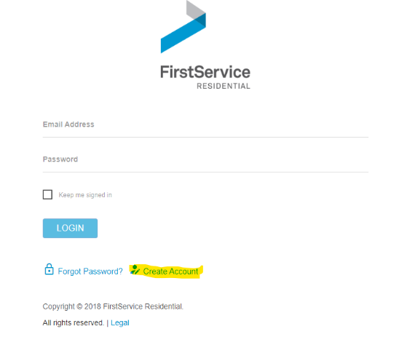
3) After entering in your contact information, you will have to verify your account. You can do this by choosing the option of entering your address or account number. You can find your contact number on your monthly billing statement.  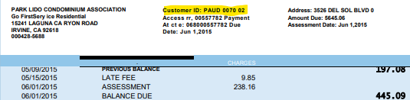 | 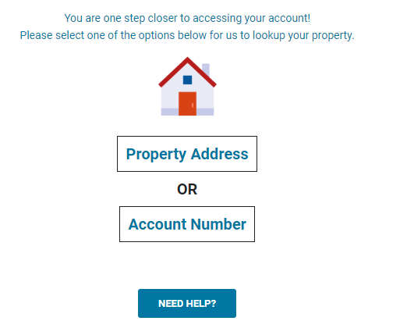
4) If you are having difficulty finding your account number or verifying your address, click the “Need Help?” button and call the Customer Care Center (833) 710-6869 and tell them the code that is provided | 